**Suggested Donations**

**Supply List for First Grade**

**Student Supplies Class Supplies**

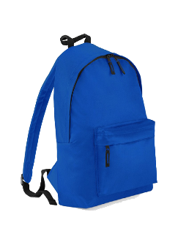

Headphones 2 Boxes of tissues

School pencil box 2 Hand soaps

Pencils (2 pkgs) 1 pkg Wipes (Lysol/Clorox)

4 Glue sticks (large size) Paper towels

2 Yellow highlighters Ziplock bags (sandwich & gallon)

4 two-pocket folders with prongs (red, blue, green, yellow) Hand sanitizer

2- Composition notebooks Wide-Ruled only (red, green)

Thank you for your donations!

The First Grade Team

**Suggested Donations**

**Supply List for First Grade**

**Student Supplies Class Supplies**



Headphones 2 Boxes of tissues

School pencil box 2 Hand soaps

Pencils (2 pkgs) 1 Hand sanitizer

4 Glue sticks (large size) 1 pkg Wipes (Lysol/Clorox)

2 Yellow highlighters Ziplock bags (sandwich & gallon)

4 two-pocket folders with prongs (red, blue, green, yellow) Paper towels

2- Composition notebooks Wide-Ruled only (red, green)

Thank you for your donations!

The First Grade Team